COMP3011 Computer Graphics
Spring 2026
Assessment 2
Report Sheet

Submit this report to Moodle.
Student Name: _Maxim Carr_
Student ID: _20346331_
Username: psymc9
I agree for my code & report to be published, with my name, to future students as an example (yes/no): __Yes__
Introduction
Please explain why you implemented this scene | Describe your inspirations | Provide a general description of the scene.
I chose this beach at night scene firstly as it provided easy opportunities to implement the objectives, such as moving objects and transparency. It’s also extendable, so features can be added or made more complex such as procedural generated terrain complexity and more objects. | I was inspired by the large number of open world survival games released following the popularity of Minecraft. The beach is like SurvivalCraft’s spawn region. The terrain resembles that from 7 Days to Die. These inspirations led to the implementation of everything else. Objects, camera and terrain implementations were chosen to fit the vision. | This scene is a beach at night-time. The user can walk across the terrain, which is infinite in 3 directions: inland and across the beach in both directions. There’s a football to play with and a night sky to look at.
TR 2 – 3D Modelling
Object 1 - procedurally generated
Please give a screenshot | reference specific code filename and line number | Description of object
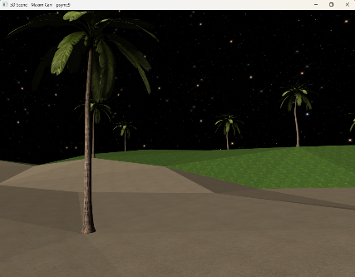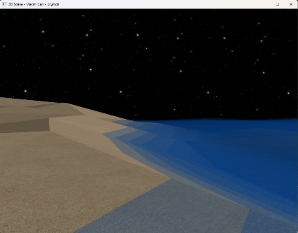 | Procedurally generated terrain: 3DScene.cpp: Lines 165-258, 373-407, 580-583, 597, 598. load_object.h: 32-65, 89-128.  Procedurally generated trees: 3DScene: Lines 410-429, 600. load_object.h: 149-168.  Procedurally generated sea: 3DScene: lines: 111-126, 433-469. | Terrain: the ground, made up of 100*100 tiles that stitch together at edges.  Tree: A palm tree that is spawned repeatedly.  The sea is procedurally generated in squares around the user and layer on layer to give depth.
Object 2 - OBJ parser
Please give a screenshot | Provide the URL for the OBJ files you submitted | Description of object.
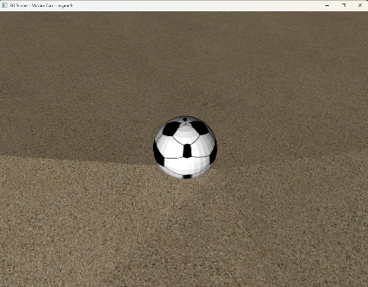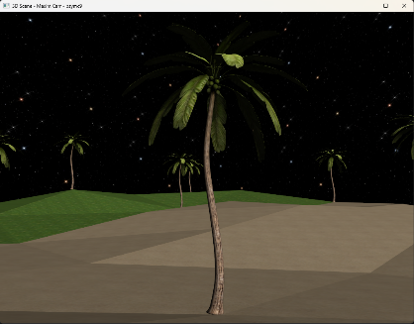 | The ball was made by me in Blender. It can be found in the objs directory  Tree: https://free3d.com/3d-model/-palm-tree-v1--283200.html?dd_referrer=.  I then resized, rotated and exported it to ensure compatibility using Blender.  All other objects made by me using Blender or manual vertex spec. They can be found in the objs directory. | A UV Sphere with a football texture that the user can kick around.  Tree: A palm tree that is spawned repeatedly.
TR 3 – 3D Transformations
Object 1 - procedurally generated
Please give a screenshot of transformed object | reference specific code filename and line number | Description of transformations
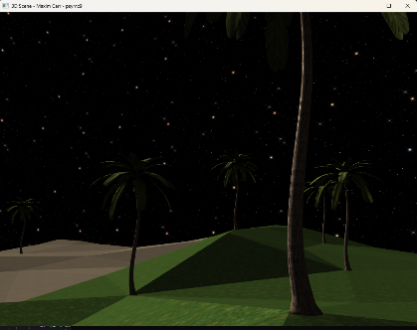 | Terrain: 3DScene.cpp: Lines 165-258, 373-407, 580-583, 597, 598.  Trees: 3DScene: Lines 410-429, 600. load_object.h: 149-168. | The terrain automatically translates itself to make a continuous varying floor based off user X and Z values.  The trees translate themselves to provide trees wherever the player walks. They are each rotated to give a slightly different appearance from each other.
Object 2 - OBJ parser
Please give a screenshot of transformed object | reference specific code filename and line number | Description of transformations
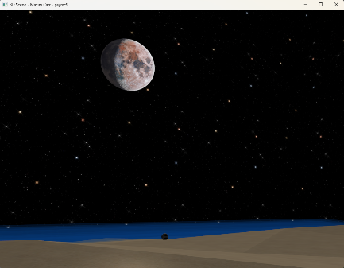 | Moon: 3DScene.cpp: lines 335 - 349.  Skybox: 3DScene.cpp: lines 324 – 332.  Sea: 3DScene.cpp: lines 111-126, 433 – 468. | The moon is translated to the position of where the directional light is coming from, then follows the user with another translation to remain in view.  The skybox is scaled to the render distance of 100*100*100. It is then moved so 0,0,0 is the centre and then follows the user as they move with another translation.  The sea is generated, then it progressively is translated in the +Z direction to give the impression of waves. Half the sea tiles are rotated 180 degrees for the same reason.
TR 3 – Animation
Please give a screenshot of animated object | reference specific code filename and line number | Description of animation
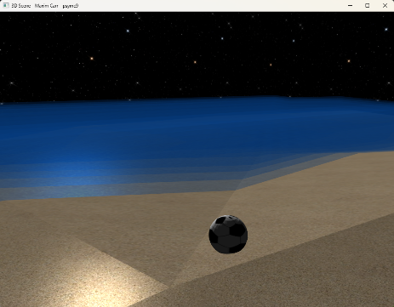 | Sea: 3DScene.cpp: lines 433 – 468, terrain.h: all of file.  Ball: ball.h: lines 39-135. | The sea is translated towards the +Z direction to give the impression of waves.  The user can kick the ball by walking into it. The ball then goes through a keep-it-up animation.
TR 4 – Camera
Please give a screenshot | reference specific code filename and line number | Description of camera
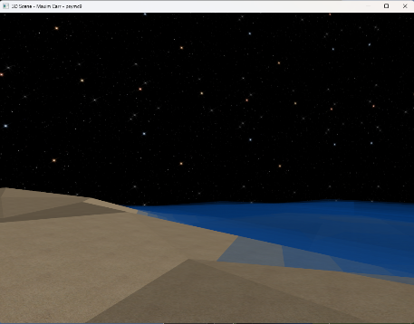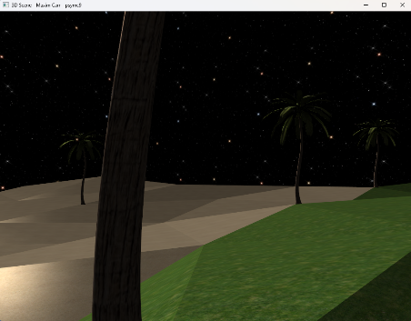 | camera.h: All of file. | The camera is built on the Model-Viewer camera.h implementation from Lab6. The movement controls are mapped to WASD.  The camera can ‘crouch’ by holding left control which reduces the camera’s height.  By holding shift, the camera’s speed is halved giving a run/walk animation difference.  The camera has a jump animation which can be seen by pressing Space. The jump goes up to 1 unit in height, before returning to the ground.
TR 5 – Texture
Object 1 - procedurally generated
Please give a screenshot | reference specific code filename and line number | Description of texture
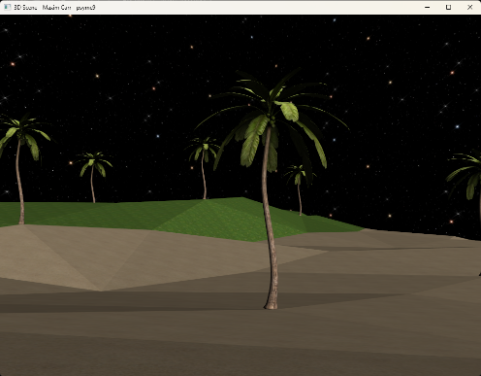 | texture.h: lines: 7-25.  3DScene.cpp: 609-616. | The textures are loaded from files and are applied to the models. The terrain, sea and skybox textures are seamless to allow for procedural generation.
TR 6 – Lighting
Object 1 - procedurally generated
Please give a screenshot | reference specific code filename and line number | Description of lights on object
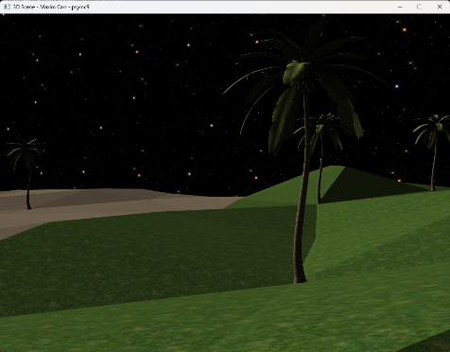  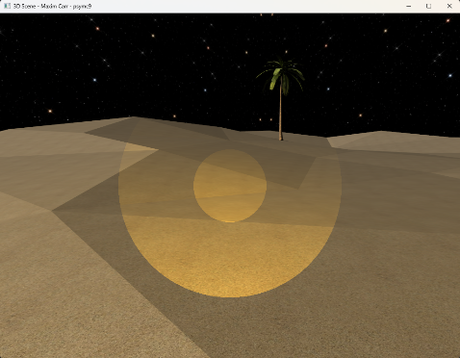 | 3DScene.cpp: lines: 149-151, 497-500.  triangle.frag: lines 39-55, 113-128.  3DScene.cpp: lines: 150-153, 292-296, 501-503.  triangle.frag: lines 57-75, 113-128. | The first image shows the directional light on the terrain and the trees. It comes from the direction of the moon.  By holding F, a flashlight is displayed adding a spotlight to the scene. Here you can see it on the terrain of the beach, combining with the directional moonlight.
Object 2 - OBJ parser
Please give a screenshot | reference specific code filename and line number | Description of lights on object
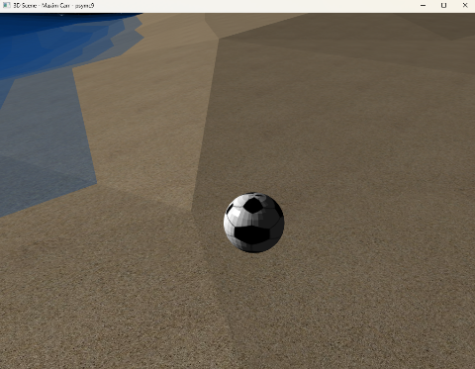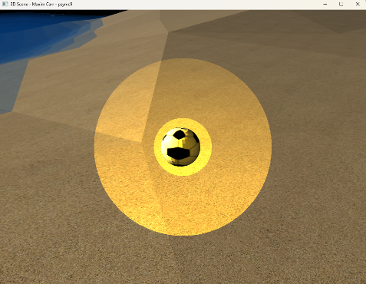 | 3DScene.cpp: lines: 149-151, 497-500.  triangle.frag: lines 39-55, 113-128.  3DScene.cpp: lines: 150-153, 292-296, 501-503.  triangle.frag: lines 57-75, 113-128. | The first image shows the directional light on the terrain and the ball. It comes from the direction of the moon.  By holding F, a flashlight is displayed adding a spotlight to the scene. Here you can see it on the ball OBJ’s surface, combining with the directional moonlight.
TR 7 - Shadow
Object 1 - procedurally generated
Please give a screenshot | reference specific code filename and line number | Description of shadow on object
 | 3DScene.cpp: lines: 472-514, 742-752.  shadow.vert: all of file.  shadow.frag: all of file.  triangle.frag: 51-52.  shadow.h: all of file. | The shadows didn’t work with the procedurally generated terrain at all, and I ran out of time to fix it. I’ve left the implementation in the code for review.
Object 2 - OBJ parser
Please give a screenshot | reference specific code filename and line number | Description of shadow on object
 | 3DScene.cpp: lines: 472-514, 742-752.  shadow.vert: all of file.  shadow.frag: all of file.  triangle.frag: 51-52.  Shadow.h: all of file. | The setup_shadow function didn’t work with the procedurally generated terrain, and I ran out of time to fix it. I’ve left the implementation in the code for review.
TR 8 - Interactive object
Please give a screenshot | reference specific code filename and line number | Description of interactive object
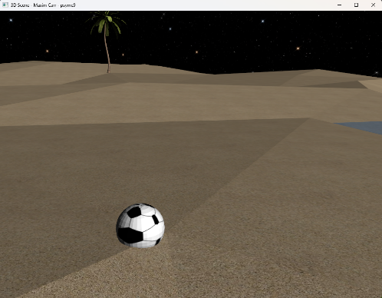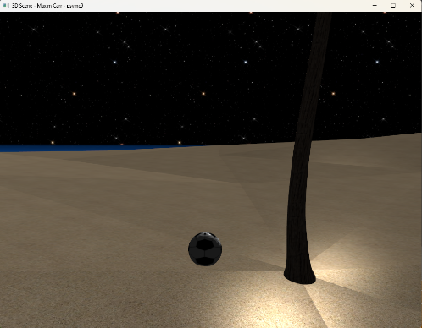 | ball.h: all of file.  camera.h: 87-146.  load_object.h: 32-64 (gets faces for collision testing) | The ball can be kicked by walking into it and therefore can be moved around the world.  The floor has collisions, meaning the camera’s Y position changes as it moves across the surface, giving the impression of climbing and descending the contours of the terrain.  The ball also interacts with the terrain through collision testing.
TR 9 – Curves
Please give a screenshot | reference specific code filename and line number | Description of curves
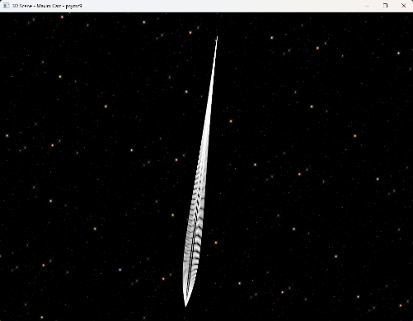 | 3DScene.cpp: 543-575, 677-685, 754-779.  casteljau.h: all of file.  point.h : all of file | In the sky there’s a comet made up of multiple Bezier curves each with 5 control points and 128 evaluations. They’re joined together, then flipped across the Z axis using scale to render the other side.
TR 10 – Transparency
Please give a screenshot | reference specific code filename and line number | Description of transparency
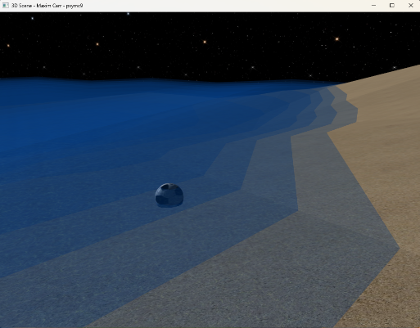 | triangle.frag: 124  texture.h: 20 | The sea is made up of multiple semi-transparent layers stacked on top of each other for a depth effect. It also enhances the look of the waves. This screenshot shows that effect on the sea itself, the ball and the sand.  The moon also has a transparent background to not block any of the night sky.
R&D
Please provide details of any research and development you conducted, as additional techniques not in the lecture notes.
Please give a screenshot | reference specific code filename and line number | Description of Research including websites, articles, references, etc.
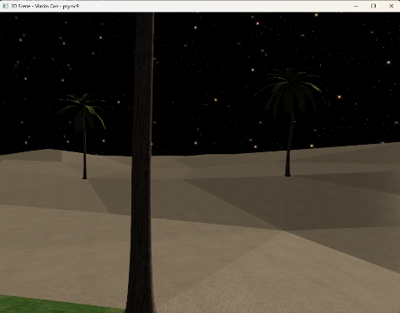 | 3DScene.cpp: 165 – 258.  camera.h: 87-146. | Research on collision detection, building on the triangle intersection logic from Part A of this CW.

